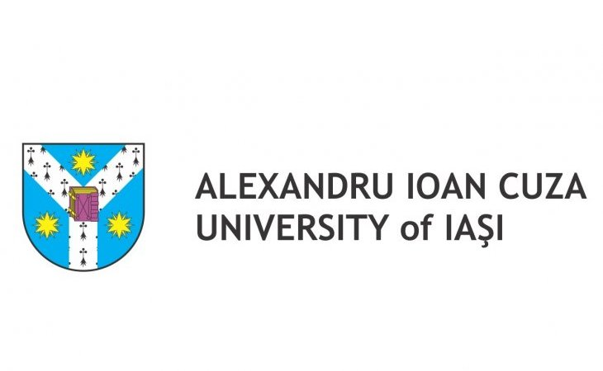 | 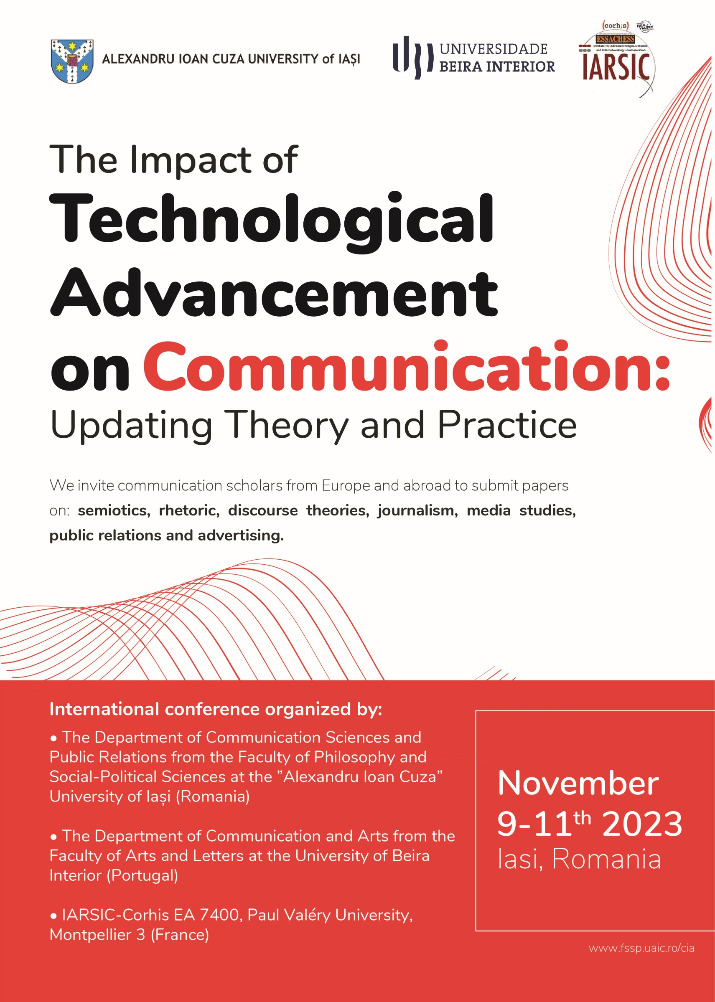 | 

4th International Conference „Communication in Action:
From Theory to Practice and Back”
Emerging Technologies in Communication: Best Practices and Theoretical Frameworks for Professional Success
7-9th November 2024, Iasi, Romania

TITLE

Surname, name, Academic title
Abstract: (200-300 words)
………………………………………………………………………………………………………………………………………………………………………………………………………………………………………………………………………………………………………………………………………………………………………………………………………………………………………………………………………………………………………………………………………………………………………………………………………………………………………………………………………………………………………………………………………………………………………………………………………………………………………………………………………………………………………………………………………………………………………………………………………………………………………………………………………………………………………………………………………………………………………………………………………………………………………………………………………………………………………………………………………………………………………………………………………………………………………………………………………………………………………………………………

Keywords: (5-7)
………………………………………………………………………………………………………………………
………………………………………………………………………………………………………………………

Institution / organization, address; e-mail, phone Note: If you want to submit a panel proposal, please send it by email to ciaconference@uaic.ro . Acceptance of a paper implies that at least one of the authors must attend onsite to the conference and present the paper.

