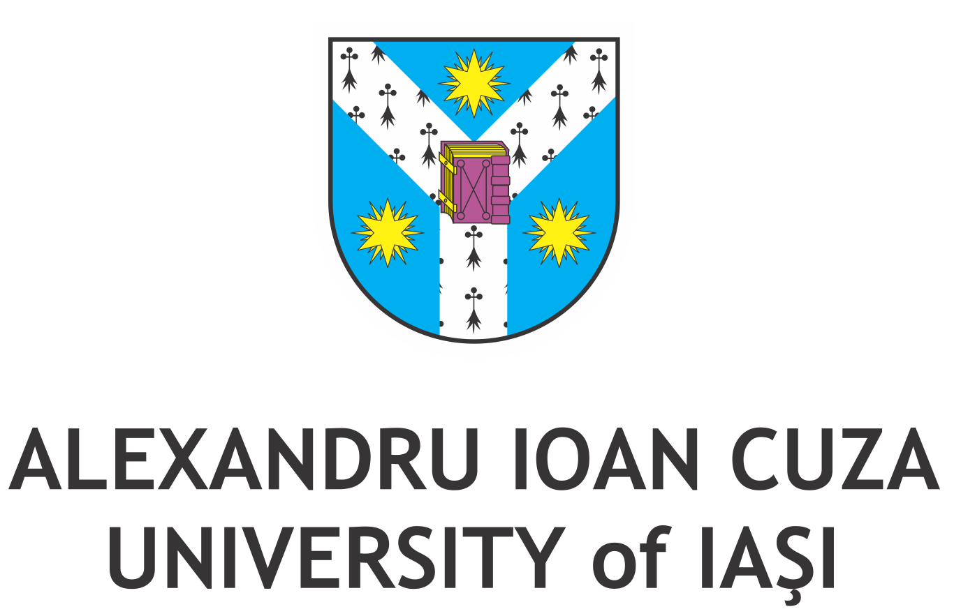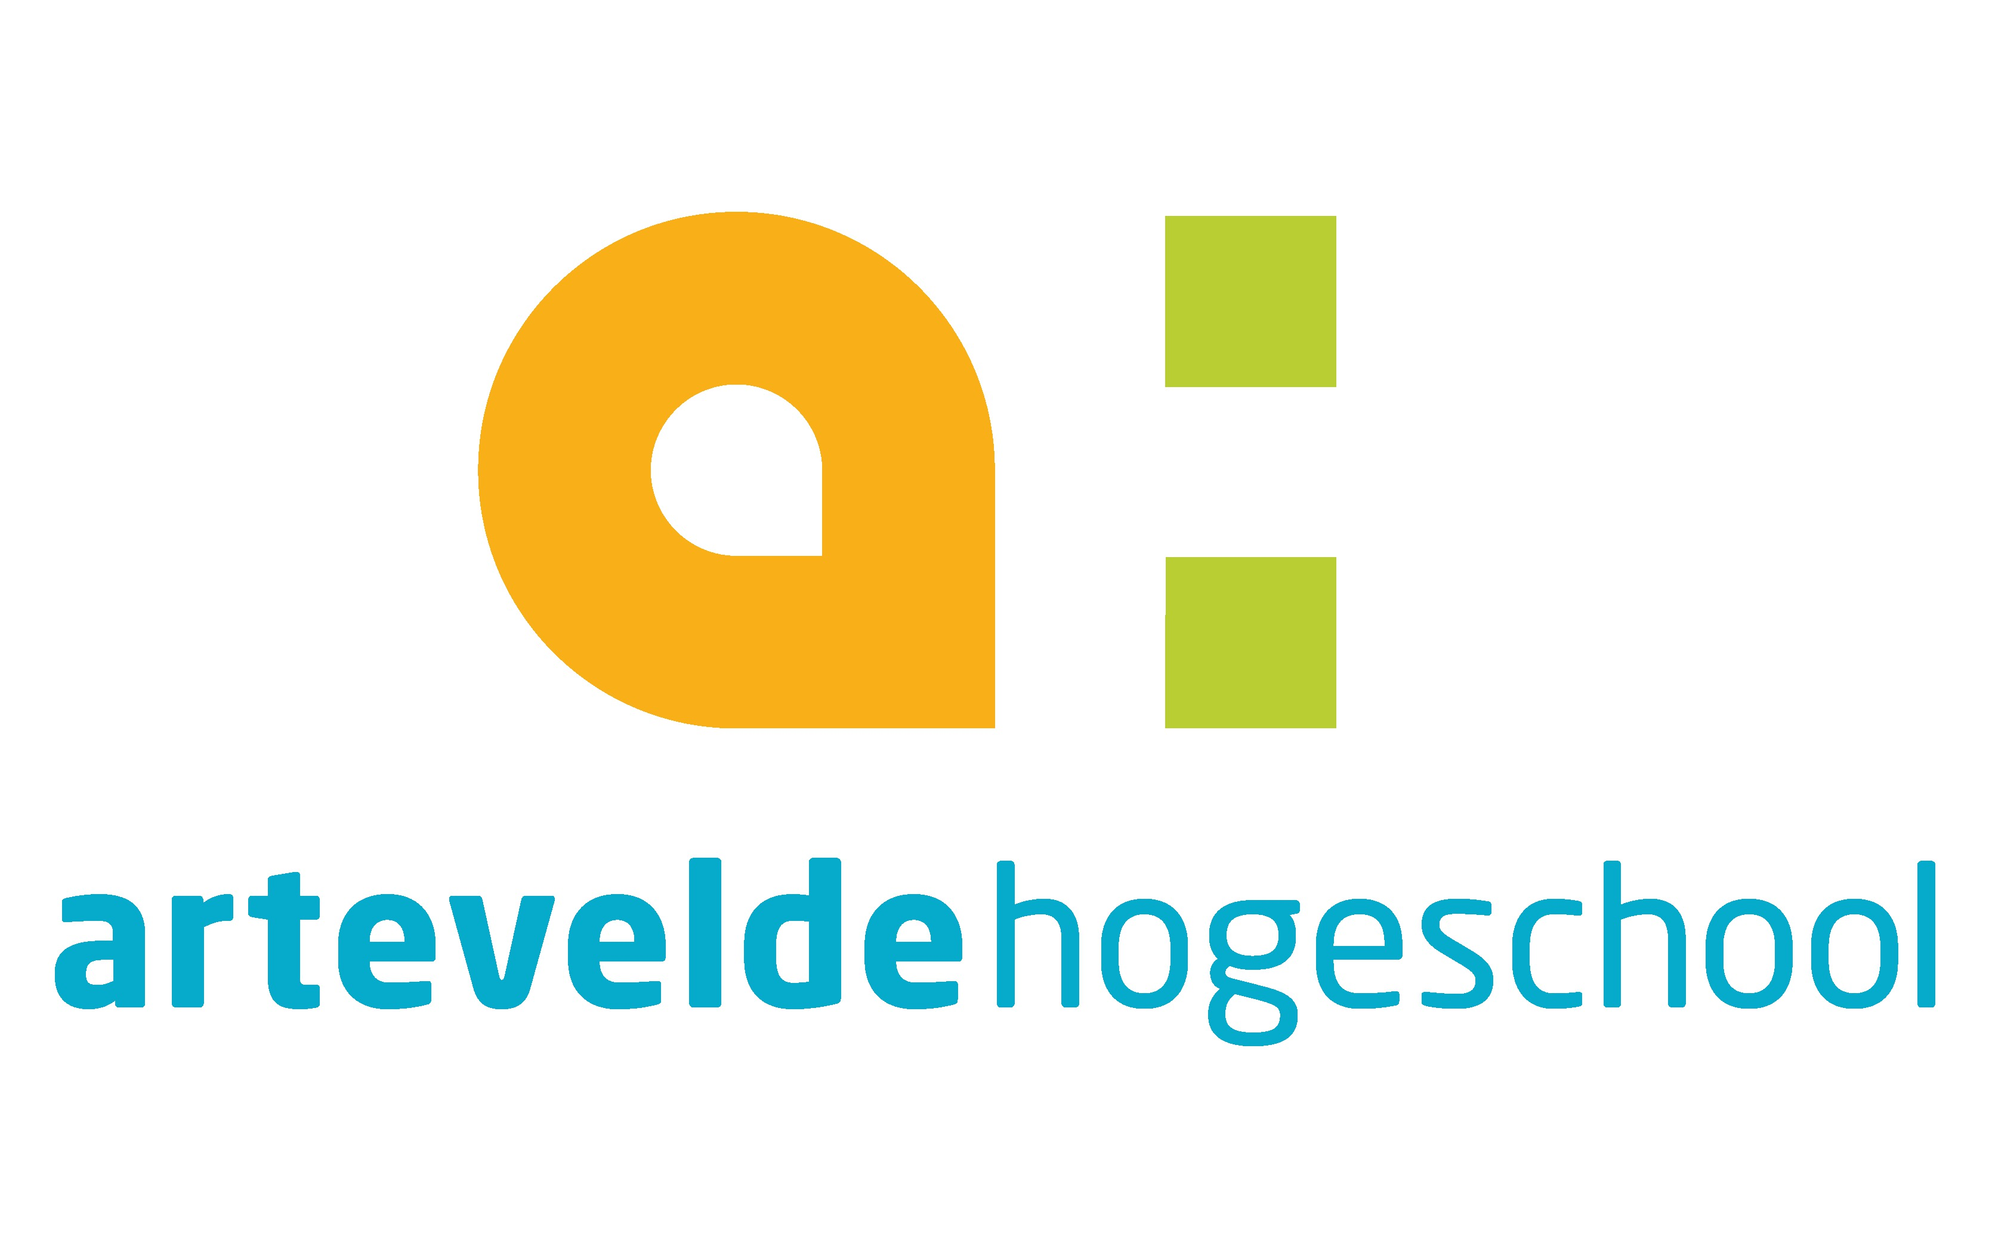

2nd International Conference “Communication in Action:
From Theory to Practice and Back"

7-9th November 2019, Iași, Romania

TITLE
Surname, name, Academic title

Abstract: (150-200 words)
Your Text Here Your Text Here Your Text Here Your Text Here Your Text Here Your Text Here
Your Text Here Your Text Here Your Text Here Your Text Here Your Text Here Your Text Here
Your Text Here Your Text Here Your Text Here Your Text Here Your Text Here Your Text Here
Your Text Here Your Text Here Your Text Here Your Text Here Your Text Here Your Text Here
Your Text Here Your Text Here Your Text Here Your Text Here Your Text Here Your Text Here
Your Text Here Your Text Here Your Text Here Your Text Here Your Text Here Your Text Here
Your Text Here Your Text Here Your Text Here Your Text Here Your Text Here Your Text Here
Your Text Here Your Text Here Your Text Here Your Text Here Your Text Here Your Text Here
Your Text Here Your Text Here Your Text Here Your Text Here Your Text Here Your Text Here
Your Text Here Your Text Here Your Text Here Your Text Here Your Text Here Your Text Here
Your Text Here Your Text Here Your Text Here Your Text Here Your Text Here Your Text Here.

Keywords: (5-7)
Keyword 1, Keyword 2, Keyword 3, Keyword 4, Keyword 5.
Section (1 - Semiotics, rhetoric, and discourse theories, 2 - Journalism and media studies, 3 - Public relations, and 4 - Advertising):
Section 3 - X

Institution / organization, address; e-mail, phone Note: If you want to submit a panel proposal, please send it by email to Rareș Obadă, email: daniel.obada@uaic.ro. Acceptance of a paper implies that at least one of the authors must attend the conference and present the paper.

