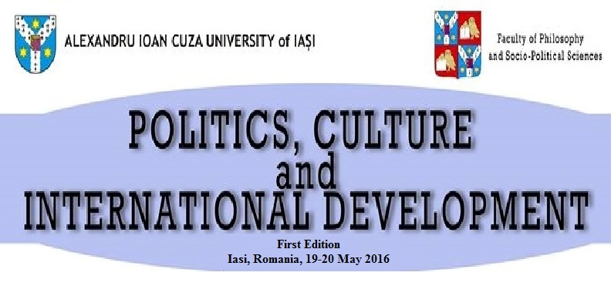
“Al. I. Cuza” University of Iasi
Faculty of Philosophy and Socio-Political Sciences
International Development Studies Program
International Student Conference
“Politics, Culture and International Development”
Iași, ROMANIA, 19-20 May 2016

Call for papers

The first edition of the International Conference “Politics, Culture and International Development” will take place at Iasi, between the 19th and 20th of May 2016. The precise schedule and other organizing aspects will be announced two weeks prior to the event.
The purpose of the conference is to bring together students from multiple areas of study in order to develop an exhaustive and multidisciplinary on the current trends and patterns of international development and to identify future tendencies in international development studies. In this respect, participants are free to present case studies, theoretical papers and/or results of personal research. The conference will be structured on thematic panels, in accordance with the topics selected by the participants.
This conference is aimed at bachelor, masters and PhD students who have interests in the fields of international relations, political sciences, anthropology, development economics, cultural studies, environmental studies, geopolitics etc.
The main theme of the conference comprises a vast array of issues and concerns regarding the status and perspectives of international development. On a general level, international development studies analyze the social, political and economic changes that interfere with development. In this sense, increased attention is paid to concepts such as inequality, globalization, structural poverty, environmental degradation and gender relations. On a more specific level, international development is of paramount importance in identifying both the specificities of conflictual areas and the optimal instruments for conflict resolution.
At the same time, the increasing role of international organizations has led to a higher degree of centralization of decision-making processes in the international system. In spite of this fact, these organisms have often bred dissensions both on an internal and external level, leading to decisional crises and tense situations. Consequently, a detailed analysis of the way in which international organizations work and interact can provide a better understanding of the tendencies and patterns that occur on the international scene.
Therefore, the conference is conceived so as to encourage multidisciplinary debates regarding the key-issues in international development studies not only from a theoretical perspective but also from an empirical one. All contributions that explore the connections between the cultural, political, economic and societal aspects of international development will be appreciated. At the same time, the conference encourages new approaches towards the topic.
We are looking forward to contributions referring and related to the following subtopics:
- Migration and refugee waves;
- Dimensions of security. Patterns and tendencies;
- Tolerance and its limitations. The case of Islam;
- Development economics: Explaining reality through economics;
- Geopolitics. Geostrategy in conflictual areas
- The dynamic of International Organizations in the contemporary world;
- Global Governance – between reality and utopia;
- Challenges and opportunities for the evolution of the European Union;
- Are the Sustainable Development Goals Sustainable?
- Challenges for democracy in Eastern Europe: Ukraine and the Republic of Moldova;
- Faces of democracy: from concept to practice;
- Military force – trademark of security? ;
- Ethics of development aid;
- Cultural Internationalism;
- Poverty and Inequality;
- Environmental protection – trends and perspectives.
Students who are interested in attending the conference can register until the 15th of April, either using the form on the website of the conference: http://register.pocidiasi.com/ or by sending an e-mail at pocidconference@gmail.com and political.science.uaic@gmail.com . At the moment of the registration, participants must submit the title of the paper, along with the abstract (300 words) and pay the registration fee, amounting to 12 euros or 13 USD (50 RON). The fee can be paid in one of the following accounts:
USD: RO48BRDE240SV30099072400
RON: RO06BRDE240SV30098942400
Account owner: Craciun Eduard
Mention: Registration fee POCID Conference Iasi
The abstract must be submitted either in RTF or PDF format and must contain the following elements:
a) the name(s) of the author(s);
b) the affiliation of the author(s);
c) e-mail address;
d) title of the paper;
e) abstract.
E-mail submissions must be accompanied by the registration form in Annex 1.
Students whose paper are accepted will be announced via e-mail until the 20th of April.
The final paper must be submitted until the 30th of April. The papers must respect the following guidelines:
- papers must be written in English in a clear and grammatically correct manner;
- pages must be numbered with Arabic numbers placed on the bottom right corner;
- papers must have between 6 and 8 pages in length (A4 format), including list of references and annexes;
- the margins of the page should be: top – 2 cm, bottom – 1.5 cm, left – 2 cm, header – 2 cm, footer – 1.5 cm, in portrait style;
- the requested font is Times New Roman, size 16 for the title of the paper, size 12 for the main body, 1.5 line spacing, indent paragraph – 1.25 cm;
- requested alignment: justified;
- participants are requested to use the Chicago system of citation (http://www.chicagomanualofstyle.org/tools_citationguide.html) ;
- papers must be submitted either in RTF or PDF format.
All papers that do not respect the writing guidelines will be sent back to the participants for correction. Each paper will be analyzed by a scientific committee, based on the content and relevance of the subject. The composition of the scientific committee will be announced prior to the event.
All papers presented at the conference will be comprised in a conference volume.
Accommodation will be provided to all foreign students. Romanian students will be accommodated in the order of their submissions, within the limit of available places. Students who cannot be accommodated will be notified at least two weeks in advance. Transport expenses must be covered by the participants. Lunch will be assured for all participant on both days of the conference.
A detailed list of partners and sponsors will be made public prior to the event.

Annex 1: Registration form for e-mail submission

International Conference
“Politics, Culture and International Development”
Iasi, 19-20 May 2016

Form of address:

First name(s):

Last name(s):

E-mail:

Phone number:

Academic title:

Institutional affiliation:

Special diet/ Allergies/ Medical conditions?

How did you find out about POCID 2016?

